1. **How do data analysts differ from data scientists?**

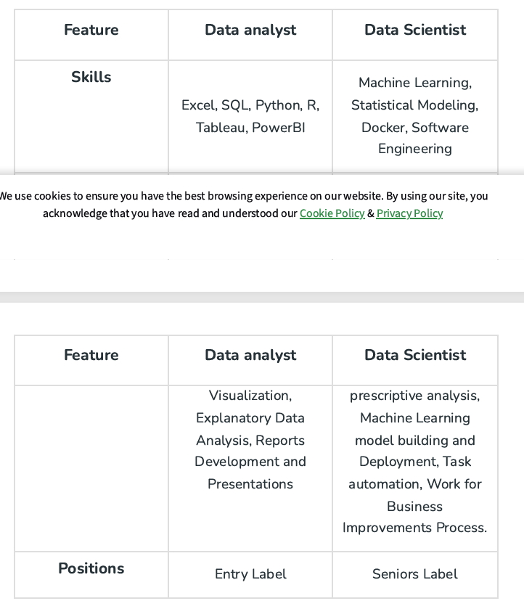

1. **How Data analysis is similar to Business Intelligence?**

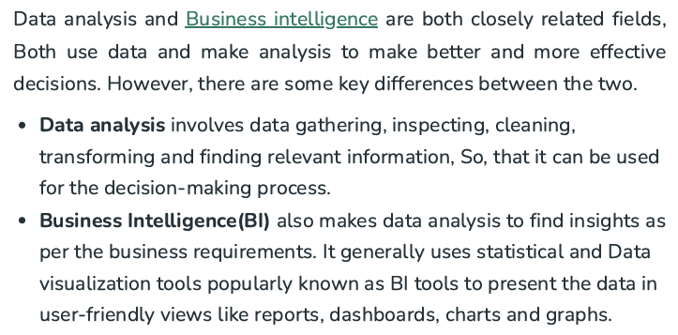

1. **What are the different tools mainly used for data analysis?**

Excel, SQL, Programming lanugaues

1. **What is Data Wrangling?**

Another name of data preprocessing.

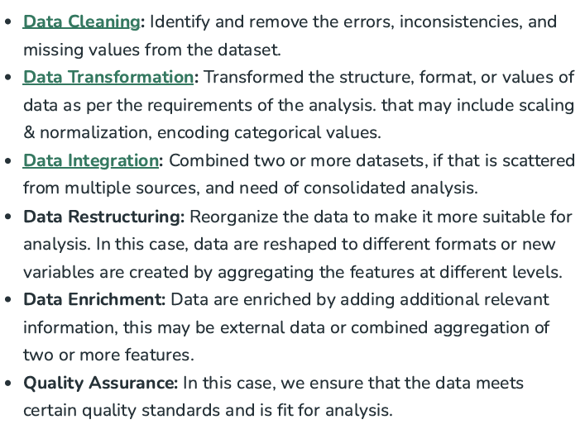

1. **Difference between descriptive, dignosis, predictive, prescriptive analysis**

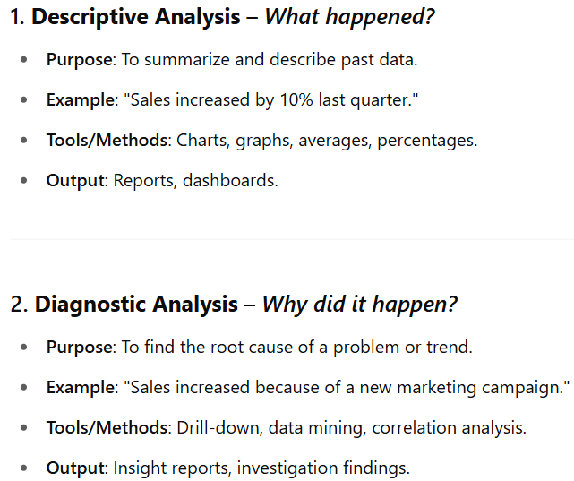

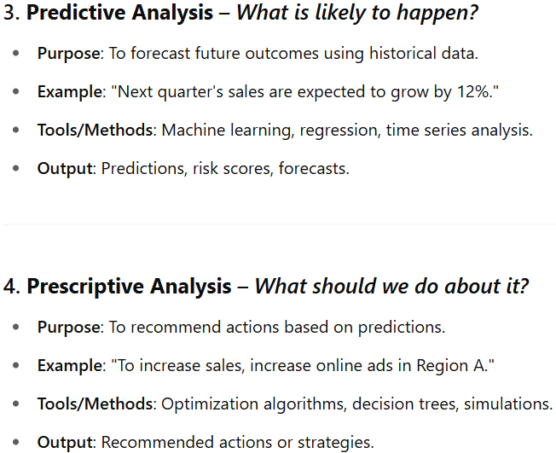

1. **Difference between univariate, bivariate, multivariate analysis**

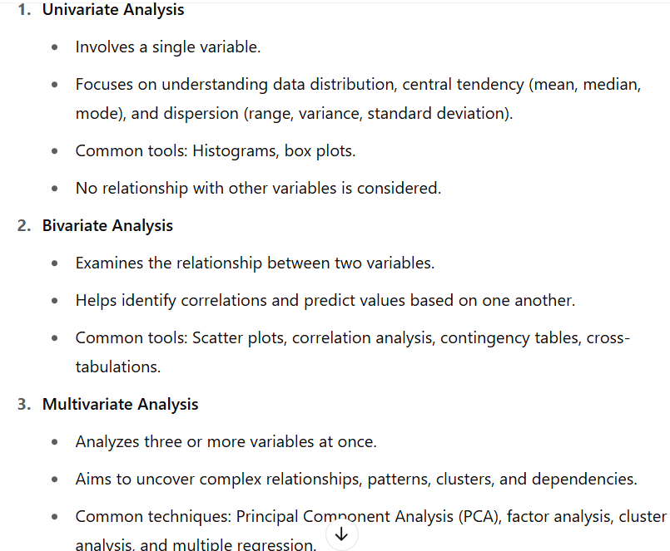

1. **Name some of the most popular data analysis and visualization tools used for data analysis**

Tableau, Power Bi, SAS, Google data studio free web based application

1. **What are the steps you would take to analyze the dataset**

• Problem Definition / Objective  
Clearly define the problem or question. Understand the goals to guide the entire analysis.

• Data Collection  
Gather relevant data from sources like surveys, databases, web scraping, etc. Ensure accuracy and representativeness.

• Data Preprocessing / Cleaning  
Clean the data by renaming columns, standardizing formats, and handling missing or inconsistent values.

• Exploratory Data Analysis (EDA)  
Use statistical and graphical methods to explore data, identify patterns, outliers, and gain initial insights.

• Data Visualization  
Create visual representations (charts, graphs) to simplify complex data, reveal trends, and communicate findings effectively to stakeholders.

1. **What is data cleaning?**

DC is a process of removing misleading info, it is the next process of data collection and loading, in data clearing we will do

1. Cleaning in inconsistent formatted data
2. Remove duplicate entries
3. Missing values
4. Outliers
5. **What is the importance of exploratory data analysis (EDA) in data analysis?**

**Exploratory Data Analysis (EDA)** is a **non-parametric** method that doesn't assume anything about the data. It plays a crucial role in the data analysis process by:

1. Providing deep insights into data patterns, distributions, and relationships between variables.
2. Assessing data quality through univariate analysis (e.g., mean, median, distribution plots).
3. Exploring relationships via bivariate and multivariate analyses (e.g., regression, correlation, scatter plots).
4. Identifying influential features using statistical measures like correlation and covariance.
5. Detecting and addressing outliers using box plots and statistical methods.

Overall, EDA forms the foundation for effective data processing, modeling, and insight generation.

1. **What is Time series analysis?**

Time Series Analysis is a statistical method used to examine and interpret data points collected over time at consistent intervals. Its primary goal is to understand the underlying patterns and predict future values.

**Key Components:**

* **Trend:** Long-term direction of the data (upward, downward, or stable).
* **Seasonality:** Repeating patterns at regular intervals (daily, monthly, yearly).
* **Cyclical Patterns:** Irregular, long-term fluctuations often linked to economic or business cycles.
* **Irregular Fluctuations:** Random and unpredictable variations not explained by other components.
* **Auto-correlations:** The relationship between current data points and past values.